7.1 Documentation Overview:
The Project Documentation Phase focuses on preparing a complete and organized record of the Salesforce-based Courier Management System. It documents the requirements, planning, system design, implementation, testing, and final results of the project.
The documentation provides detailed information about the custom objects, fields, relationships, validation rules, Salesforce Flow automation, profiles, roles, reports, and dashboards developed for the system.
Screenshots are included as visual evidence of the implemented features. They demonstrate the actual Salesforce application interface, customer records, shipment records, delivery-agent records, delivery updates, invoices, automation, security settings, reports, and dashboard.
The documentation serves as a reference for understanding the complete development process and provides supporting evidence that the major features of the Courier Management System were implemented and tested successfully.

7.2 Documentation Contents
The project documentation is organized into different sections to provide a complete record of the Courier Management System. The following table presents the main contents of the project documentation.
S.No. | Documentation Section | Contents / Description
1 | Project Introduction | Abstract, objectives, scope, and project background
2 | System Analysis | Existing system, proposed system, requirements, and specifications
3 | Project Planning and Scheduling | Methodology, product backlog, sprint planning, and schedule
4 | System Implementation | Salesforce objects, fields, validation rules, Flow automation, profiles, roles, reports, and dashboards
5 | Functional and Performance Testing | Functional testing, automation testing, security testing, report testing, and dashboard testing
6 | Project Documentation | Screenshots, implementation evidence, configuration details, and supporting materials
7 | Project Demonstration | Demonstration of the major system features
8 | Project Results | Results obtained after implementation and testing
9 | Conclusion | Overall project summary and objectives achieved

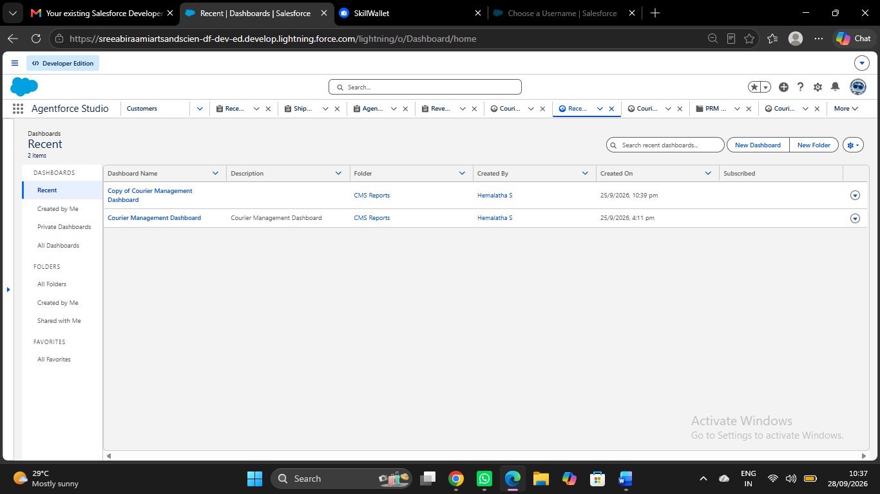
- Home/Dashboard:

- Customers:

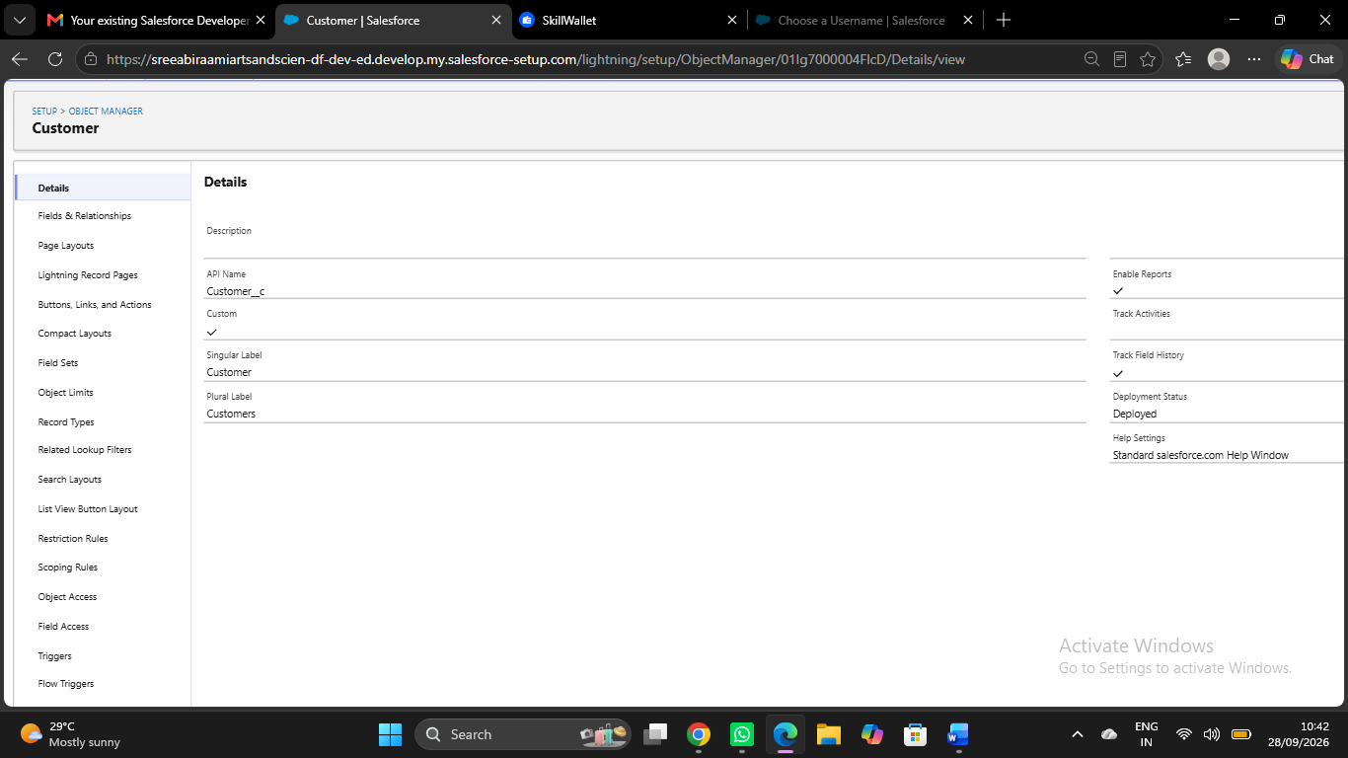

- Shipments:
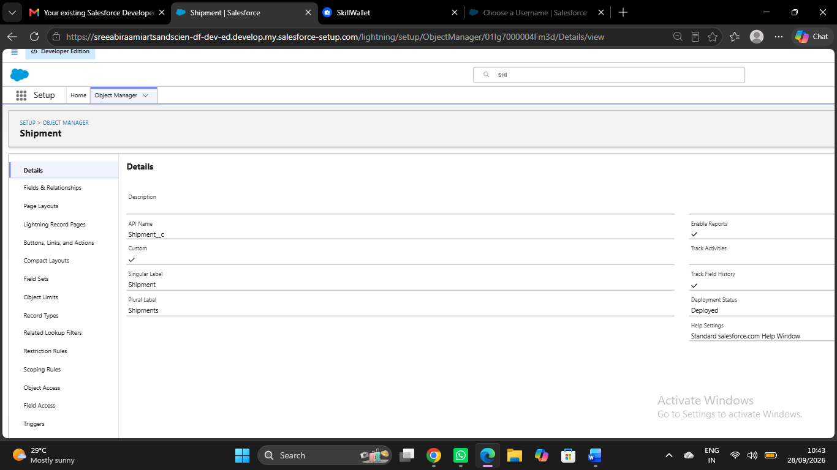

- Delivery Agents:

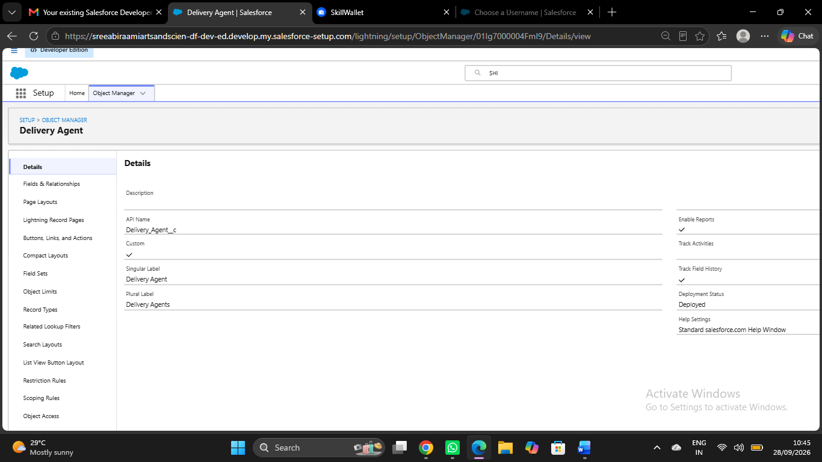

- Branches:
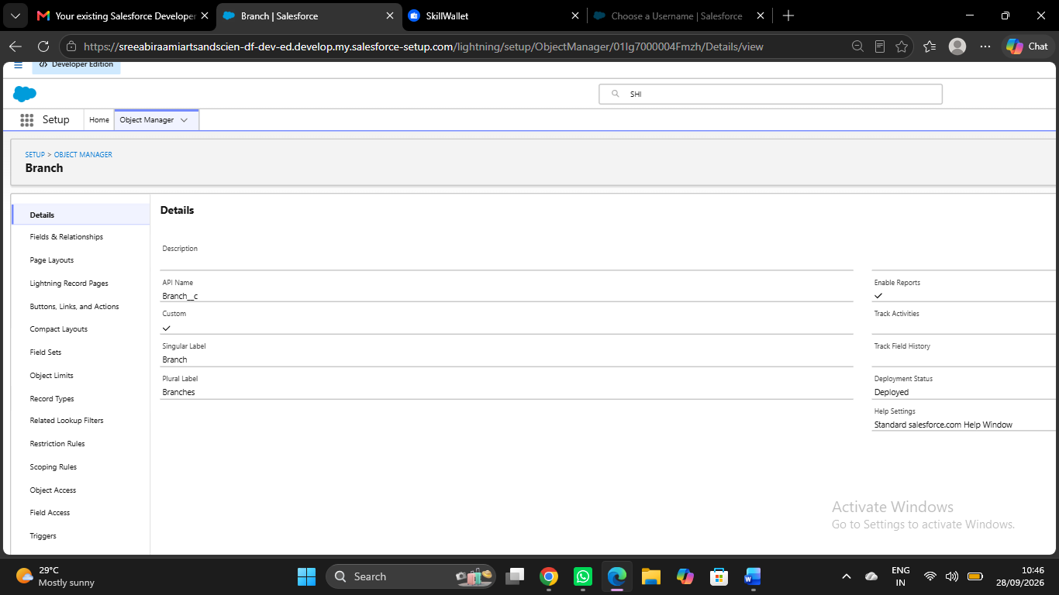

- Delivery Updates:

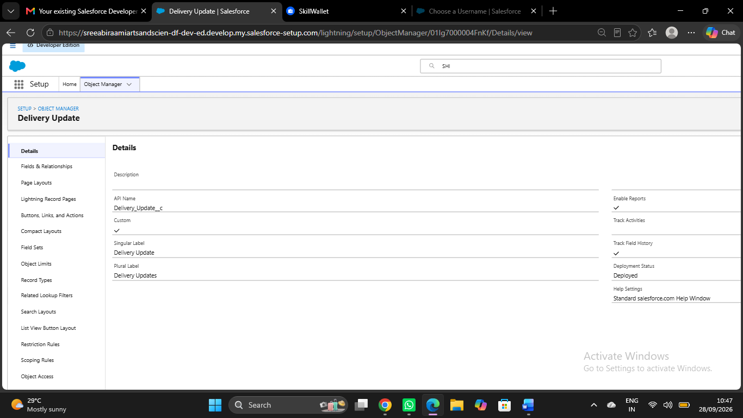

- Invoices:
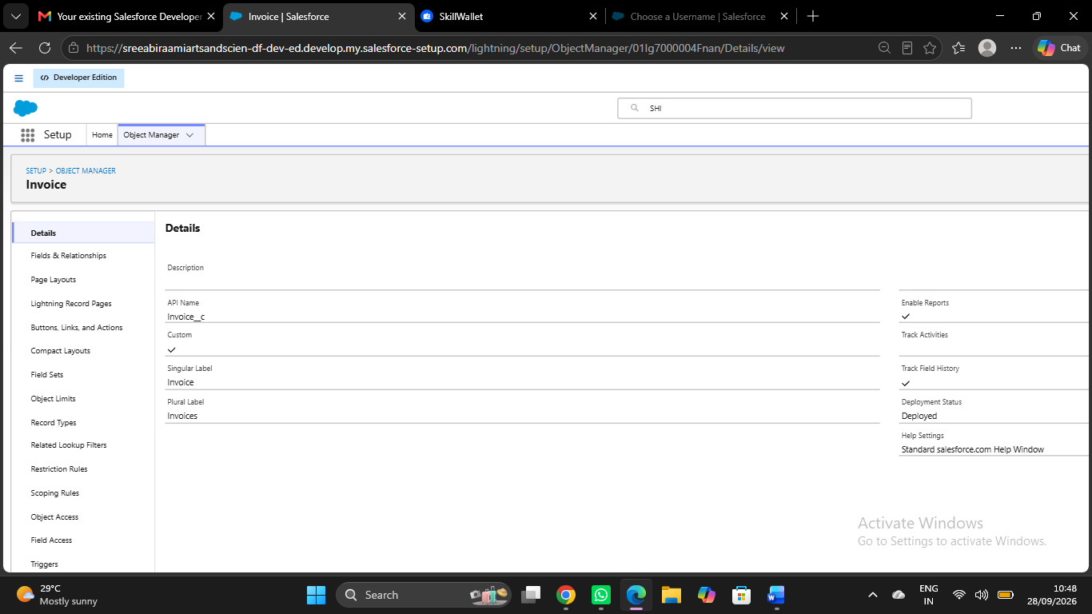

- Reports:

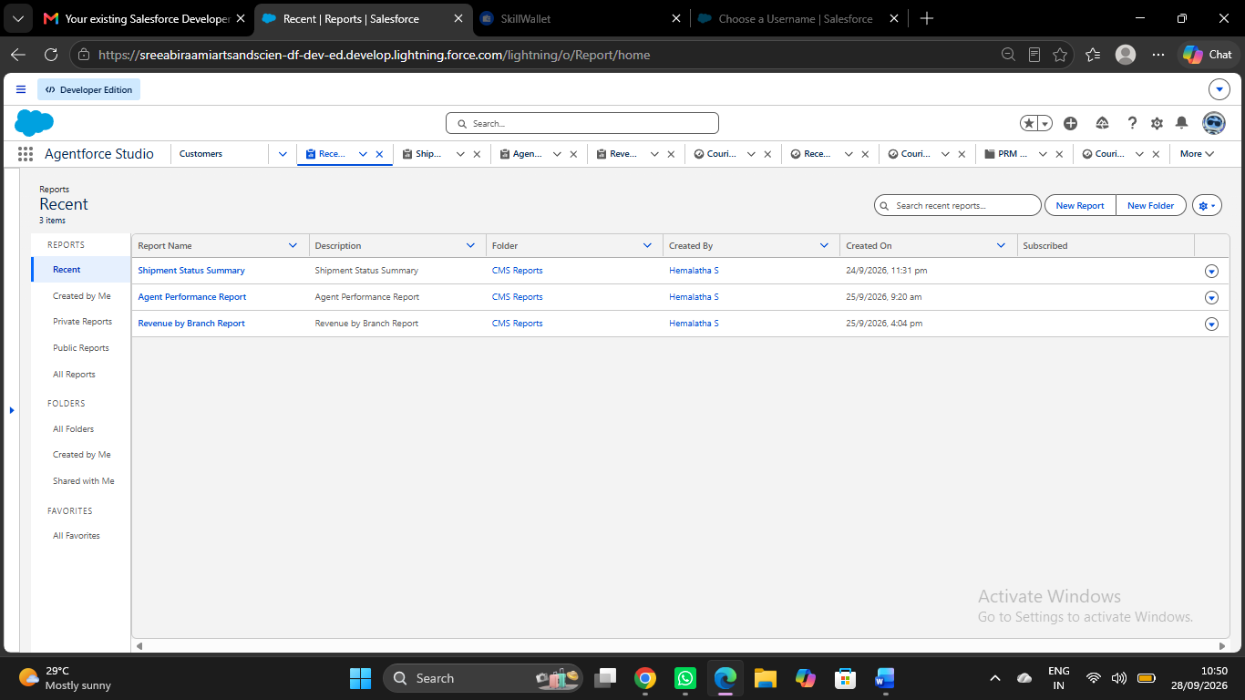

- CONCLUSION:
- The Courier Management System was successfully designed and implemented using the Salesforce platform to manage courier operations in an organized and efficient manner. The system provides centralized management of customers, shipments, delivery agents, branches, delivery updates, and invoices.
- Salesforce features such as custom objects, validation rules, Flow automation, profiles, roles, reports, and dashboards were implemented to improve data management and reduce manual activities. The automated shipment-status update helps maintain accurate delivery information, while reports and dashboards provide useful information for monitoring courier operations.
- The system was tested through functional, security, automation, reporting, and performance testing. The testing results confirmed that the major features of the system work according to the defined requirements.
- Overall, the project demonstrates how Salesforce can be used to develop a structured and automated Courier Management System. The implemented system provides a foundation for future enhancements such as mobile access, customer notifications, online payment integration, real-time tracking, and advanced analytics.

